

AGILE SYSTEMS

28th February 2020

ADIRA-STRONG AND NOBLE

A WOMEN SECURITY APP

**Submitted To:**

**Dr. Durgansh Sharma**

**Associate Professor**

**University of Petroleum and Energy Studies**

**BY: MIND BENDERS**

|  |  |  |
| --- | --- | --- |
|  |  |  |
| **GROUP MEMBERS** | **ROLL NO.** | **SAP ID** |
| Aditi Sinha | R174218003 | 500066712 |
| Khushboo Saini | R174218021 | 500066934 |
| Priyanshi Gupta | R174218038 | 500070513 |

Table of Contents

AGILE MANIFESTO 3

PRINCIPLES 4

ABSTRACT 5

INTRODUCTION 6

PROBLEM STATEMENT 8

REVIEW 9

Description 9

Pros 9

Cons 9

SYSTEM MODULES 10

Profile Module 10

Police Station 10

Emergency Contacts 10

Emergency Button 10

ENTITY RELATIONSHIP DIAGRAM 11

DATA FLOW DIAGRAM 12

DFD LEVEL – o 12

DFD LEVEL – 1 12

DFD LEVEL-2 ……………………………………………………………………………………………………………………………………13

METHODOLOGY …………………………………………………………………………………………………………………………….14

DATA ANALYSIS…………………………………………………………………………………………………………………………..15

# AGILE MANIFESTO

We are uncovering better ways of developing software by doing it and helping others do it. Through this work we have come to value:

* **Individuals & interactions** over processes and tools.
* **Working software** over comprehensive documentation.
* **Customer collaboration** over contract negotiation.
* **Responding to change** over following a plan.

That is while there is value in the items on the right, we value the items on the left more.

Kent Beck James Grenning Robert C. Martin

Mike Beedle Jim Highsmith Steve Mellor

Arie van Bennekum Andrew Hunt Ken Schwaber

Alistair Cockburn Ron Jeffries Jeff Sutherland

Ward Cunninghum Jon Kern Dave Thomas

Martin Fowler Brain Marick

# PRINCIPLES

*We follow these principles:*

* Our highest priority is to satisfy the customer through early & continuous delivery of valuable software.
* Welcome changing requirements, even late in development. Agile processes harness change for the customer’s competitive advantage.
* Deliver working software frequently, from a couple of weeks to couple of months, with preference to the shorter timescale.
* Business people and developers must work together daily throughout the project.
* Build projects around motivated individuals. Give them the environment and support they need and trust them to get the job done.
* The most efficient & effective method of conveying information to & within a development team is face-to-face conversation.
* Working software is the primary measure of progress.
* Agile processes promote sustainable development. The sponsors, developers & users should be able to maintain a constant pace indefinitely.
* Continuous attention to technical excellence & good design enhances agility.
* Simplicity-the art of maximizing the amount of work not done is essential.
* The best architectures, requirements, and designs emerge from self-organizing teams.
* At regular intervals, the team reflects on how to become more effective then tunes and adjusts its behavior accordingly.

# ABSTRACT

Our venture “**ADIRA-STRONG & NOBLE**” is a security based application which will be utilized for self- assurance. We thought of the idea ‘ADIRA’ (A women security app) which is a Hebrew word that implies Strong noble and powerful.. It is based on android application. This application can be utilized on smart phones, tablets, television. In short, what the client need to do is to link herself from the app & when the client faces any risk, she simply needs to dial that emergency contact number with the goal that the client’s relatives can follow them. The app will likewise give the maps to the closest police stations and will also map the places where the user can learn self-defence and can shield herself from the foe & permit to have a correspondence through online message interface, audio recording & a video recording interface.

# INTRODUCTION

* The closet to “**INDIVIDUALS AND INTERACTIONS over processes &** **tools”** is an initiative taking process as our project indulges with the user and interact with the relative as the user finds any threats around her. It takes an initiative for valuing people more highly because they respond to the needs of the user. Communication & interactions between the individuals justifies a proper requirement when a need arises.
* People are adapted of using mobile phones everywhere that traits a **“WORKING SOFTWARE over comprehensive documentation”** that is diversified for a social cause or

mis-happening with anyone around. The efficient way to minimize the chances of becoming a victim of violent crime is to identify and resource yourself from the security app in order to get out of dangerous situations.

* **“CUSTOMER COLLABORATION over contract negotiation”** clarifies the user as the client collaborates throughout in the making of the development process. Waterfall model stimulates the requirement for the product, prior to negotiation. Our app accommodates with scrum development. It is trust worthy and motivates the people around for a consistent support pace.
* **“RESPONDING TO CHANGE over a following plan”** with the intention of developing plans that illustrates the approach of an individual’s capability that determines change as an expense. Our app is a positive change that will help the user in every manner by an alignment through people’s signatories. The positive changes provide an additional value that uncovers its impact on negotiation.

These 4 manifesto are meant to guide and inspire us to build secure software in an efficient way. The agile approach to software development is defined by the commitment of creating software incrementally. The approach offers new versions or releases of the software that follow brief periods of work. It may involve the collaborative work of multiple self-organizing teams composed of members who have different functional expertise but are working for the achievement of a common goal. The manifesto also wants to prioritize the creation of working software, not the generation of documentation, collaboration with the client instead of spending more time on contact negotiation.

# PROBLEM STATEMENT

Nowadays, physical harassment is one of the most common & frequently happening against females in India. The metro cities have more number of physical harassment cases compared to other countries. Developing country like India have less number of incidences where very good security facility are provided by the government but still there are many females who are facing physical harassment. It is also revealed that in 98% cases, the culprit is someone close to the victim like relative or neighbor. It is not possible to keep watch on each house every time.

**ADIRA** is a safety device available for female’s self-protection in situation like rape & assaults and adds a new perspective of using android smart phones with GPS for females safety.

* The app provides a help line number to the females.
* It also provides the live location to the given number.

# REVIEW

## Description

The app can be activated by a single click when the user feels she is in danger. The application maps the user’s location to the registered contacts for every few seconds in the form of message. The key features of this application are along with the user’s location, one of the registered contacts gets a call. Also, the registered contacts and GPS location are saved from time to time in a database.

## Pros

This app continuously fetch the location for an interval of every 30 seconds and send it to the registered contact. So, we can easily track the user and it will also send the location in the form of URL.

## Cons

This app will work at the time of danger so it is not that feasible for a user to instantly if she is in trouble. The whole process of the system is done only when the device is connected to proper mobile network, data connection of the device is on and location service in the device is switched on (GPS).

# SYSTEM MODULES

Our project contains the following four modules:

## Profile Module

Profile is an important component to users, which helps users to add her personal details.

Name, Address, Email ID, Mobile Number.

## Police Station

The user will get information about the nearer police station.

## Emergency Contacts

Required details of one who is in danger will be contacted to the right person or family members or friends or help lines.

## Emergency Button

When we sense any danger, we can escape by using emergency button.

# ENTITY RELATIONSHIP DIAGRAM

# 

# DATA FLOW DIAGRAM

## DFD LEVEL - o

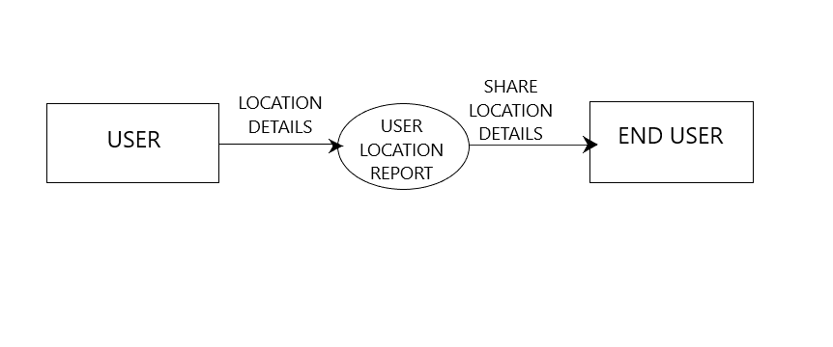

## DFD LEVEL - 1

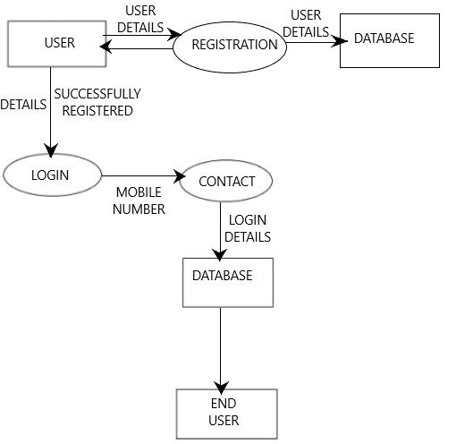

# DFD LEVEL-2

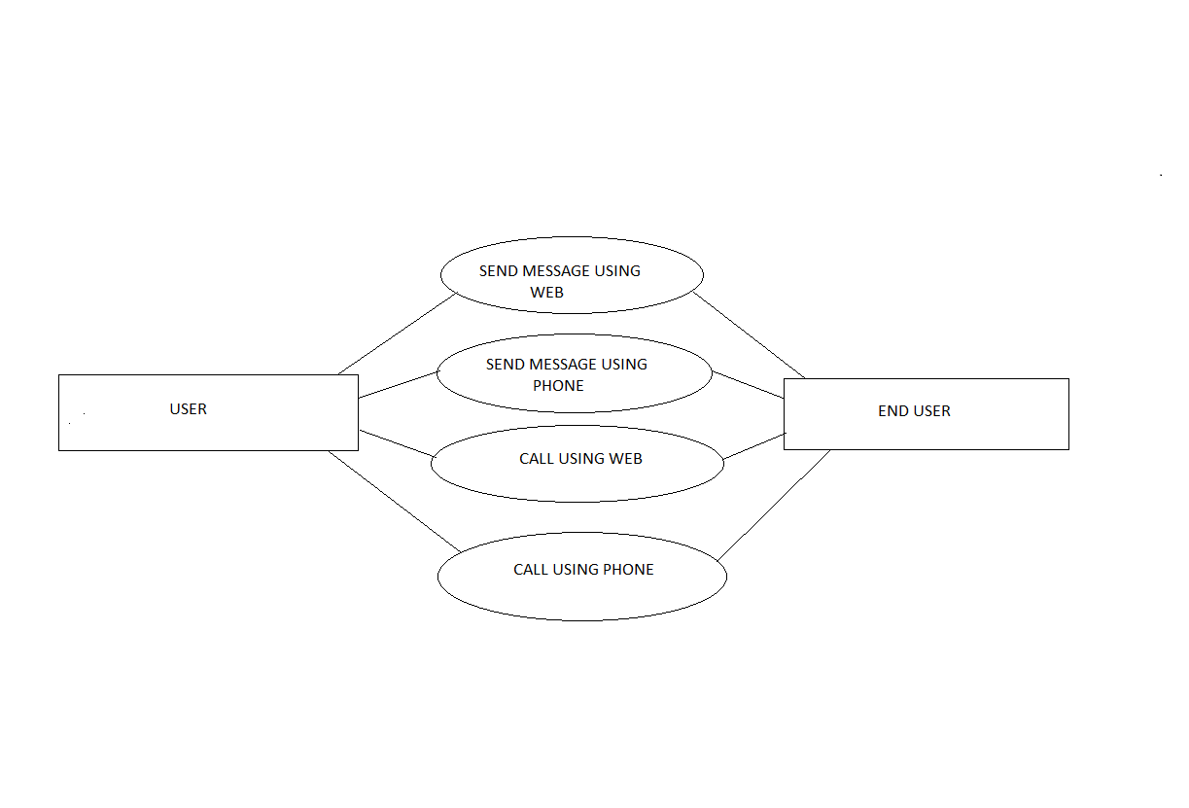

# METHODOLOGY

Personal safety has become an important issue for everyone, but specially for females. The current females safety device in the market has to push the button to send a message. It is difficult to press button in critical situation when the keypad is locked. The email consists of the following details:

* Stored details of the victim such as image of the victim, parent/guardian contact number, and address of the victim.
* Surrounding captured images.
* GPS location information about the victim along with longitude and latitude.

## DATA ANALYSIS

Survey Questions

1. Do you feel safe going out alone?

Yes-

No-

No answer-

2. Do you feel safe in day or night?

Day-

Night-

Both A and B-

No answer-

3. Females feel safe in Public Transport?

Yes-

No-

No answer-

4. Do you feel comfortable in sharing cabs?

Yes-

No-

No answer-

5. Do you carry something(like pepper spray, chilli powder etc) for your safety?

Yes-

No-

No answer-

6. Do you know any technique for your safety?

Yes-

No-

No answer

7. Are you satisfied with government initiatives for women safety?

Yes-

No-

No answer-

8. Women safety Apps are helpful?

Yes-

No-

No answer-

9. What suggestions would you like to give to increase the safety of women?

* Need more actions to be taken
* It is important to evaluate the goals and practical usefulness of a womens self-defense program .
* Just make your son understand that women are not toys.
* Govt. Should take major steps regarding this rather than just ta
* 24hrs police personnel in the trains
* Stay away from those from who u are not comfortable with.
* No idea
* Change the government rules and regulations
* Stick to your commitment to government.hang each rapist with a week even if he is a minor. Public support girls don't be watcher's or recorders
* Police must be strictly
* Everyone should be help each other at any point of time
* Women safety measures and awareness programms should bhi organizaed
* it's not about the government. it's about the education of not only boys but girls too.
* Police should be more attentive and give fast response
* Change of thought process
* Honest administration who works for the society
* Fight for safety
* We need to learn self defense and strong laws should be made against crimes
* Government should be make a strict action and rules for safety section and I m sorry to say our man and woman police staf are not helpful so make a better idea for all side of our society some how to effect the mentality of society.
* Strict Laws, women safety camps and awareness about the cause.
* Self defence should be taught to girls, right from the beginning. It should be a part of school curriculum and it should be responsibility of government as these things are not economically feasible every other girl of our country. Immediate need of systemic reforms in the women Helplines, restructured steps should be taken so that immediate help could reach the women at the Time of need.
* Take a chilly spray .etc with us
* They should make law powerful towards protection of women
* Remove crime
* We should avoid acid attack nd rape
* Dear sir/mam..thanks aap log girls ki saftey ke liye app bna rhe ho .mujhe ghr se RT ko bhr Jane m dar lgta h..ghr se bhr niklti hu toh sochti hu ki ghr safe pahuchungi bhi ya nhi..society Hume hamare kapde se judge krti h..agr humne shorts phne h toh hum Carteracterless h le suit toh hum sanskrit.. yeh soch samaj ko ander se khokla krke baith gyi h...m bhi nhi janti rape hone kb bnd hoga..bs itna samjhti hu agr hamare ghr m hum apne bhaiyo ko jis din yeh samjha diya ki jaise m teri bhn hu dusri ldki bhi kisi ki bhn ..maa or beti h agr mera bhai meri protection kr sakta h toh us ldki ko woh apni bhn kyu nhi samjh sakta...jis din ghr m beto ko beti ki respect krna sikha diya us din syd hum safe ho jayenge..

Dont trust anyone and help yourself by yourself

I think sabko apni soch achhi rakhni chiye takki koi dikkat hi na ho

Teach self defense